A solenoid valve is an electromechanical controlled valve. The valve features a solenoid, which is an electric coil with a movable ferromagnetic core in its centre. This core is called the plunger. In rest position, the plunger closes off a small orifice. An electric current through the coil creates a magnetic field. The magnetic field exerts a force on the plunger. As a result, the plunger is pulled toward the centre of the coil so that the orifice opens. This is the basic principle that is used to open and close solenoid valves.

* **Parts of the Solenoid Valve and their Working**

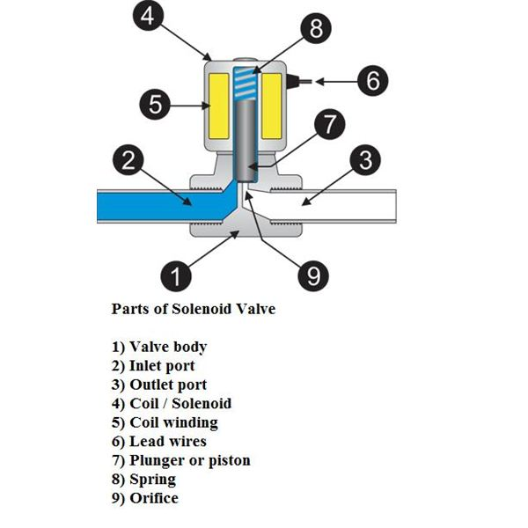

Here are the various parts of the solenoid valve and their working (please refer the figure above).

**1) Valve body:** This is the body of the valve to which the solenoid valve is connected. The valve is usually connected in the process flow pipeline to control the flow of certain fluid like liquid or air. Ordinarily the flow from the valve is controlled by the handle, but in case of the automatic valve the solenoid valve is connected to the valve.

**2) Inlet port of the valve:** This is the port through which the fluid enters inside the automatic valve and from here it can enter into the final process.

**3) Outlet port:** The fluid that is allowed to pass through the automatic valve leaves the valve through the outlet port. The solenoid valve controls the flow of the fluid from inlet port to the outlet port. The outlet port is eventually connected to the process where the fluid is required.

**4) Coil/ Solenoid:** This is body of the solenoid coil. The body of the solenoid coil is cylindrical in shape, and it is hollow from inside. The body is covered with steel covering and it has metallic finish. Inside the solenoid valve there is solenoid coil.

**5) Coil windings:** The solenoid consists of several turns of the enameled wire wound around the ferromagnetic material like steel or iron. The coil forms the shape of the hollow cylinder. Externally this coil is covered with the steel covering and inside the hollow part there is a plunger or the piston, whose motion inside the hollow space is controlled by the spring.

**6) Lead wires:** These are external connections of the solenoid valve that are connected to the electrical supply. The current is supplied to the solenoid valve from these wires. When the solenoid valve is energized, the current flows through these wires to the solenoid valve and when the solenoid valve is de-energized the flow of current stops.

**7) Plunger or piston:** This is the solid round metallic part cylindrical in shape and placed in the hollow portion the solenoid valve. When the electrical current is passed through the solenoid valve, the magnetic field is generated inside the hollow space. Due to this the plunger tends to move vertically in the hollow space. When the electrical current is stopped to the solenoid valve, the magnetic field is stopped and the plunger is remains the existing place due to the force of the spring.

**8) Spring:** The plunger moves inside the hollow space due to the action of the magnetic field against the action of the spring. The magnetic field generated inside the solenoid valve tends to move the plunger, but the spring tends to stop the motion of the plunger in which ever the position it is. This action of the spring against the magnetic field helps keeping the plunger in the position where the flow of current to the solenoid valve is stopped. The spring performs very crucial action inside the hollow space. For one, the plunger is in the vertical position, so the spring helps keeping it at the desired position instead of allowing the plunger to fall to the bottom due to gravity when the current to the solenoid valve is stopped. Secondly, the spring also prevents the movement of the plunger due to force of the fluid flowing through the valve body. If the spring was not there the plunger would have moved up when the fluid is present and moved down when the fluid is not there. Thus the spring actually forces the plunger to carry out the control of the fluid. It allows the movement of the plunger only to the extent when the electric current is flowing through the solenoid valve.

**9) Orifice:** The orifice is an important part of the valve though which the fluid is flowing. It is the connection between the inlet and the outlet port. The flow of fluid from the inlet port to the outlet port takes place from this port. In the ordinary valves, this port is covered with the valve disc at the bottom of the stem of the valve to which the handle is connected. Thus in ordinary valves, the opening of the orifice are controlled by the handle, but in case of the solenoid valves, the opening of the orifice is controlled by the plunger. The movement of the plunger is in turn controlled by the spring and the current flowing through the solenoid valve.

* If the current passing through the solenoid valve is constant, the position of the plunger and hence opening of the orifice remains constant. If the sensor senses that more flow of the fluid is required, it allows the increase in current passing through the solenoid valve, which creates more magnetic field and more upwards motion of the plunger. This leads to further opening of the orifice and more flow of the fluid from the inlet port to the outlet. If the required flow of fluid is less, the sensor allows passage of the lesser current to the solenoid valve. When the sensor senses that the fluid is no more required in the process, it stops the flow of the current to the solenoid valve completely. Due to this the solenoid valve gets de-energized and the plunger reaches the bottom most position and closes the orifice completely thus stopping the flow of fluid from the inlet port to the outlet port.
* **Working of the Solenoid Valve**

Initially the sensor senses the process towards the outlet side of the solenoid valve. When it senses that certain quantity of the flow of the fluid is required, it allows the current to pass through the solenoid valve. Due to this the valve gets energized and the magnetic field is generated which triggers the movement of the plunger against the action of the spring. Due to this the plunger moves in upwards direction, which allows the opening of the orifice. At this instant the flow of the fluid is allowed from the inlet port to the outlet port.

If the current passing through the solenoid valve is constant, the position of the plunger and hence opening of the orifice remains constant. If the sensor senses that more flow of the fluid is required, it allows the increase in current passing through the solenoid valve, which creates more magnetic field and more upwards motion of the plunger. This leads to further opening of the orifice and more flow of the fluid from the inlet port to the outlet. If the required flow of fluid is less, the sensor allows passage of the lesser current to the solenoid valve.

When the sensor senses that the fluid is no more required in the process, it stops the flow of the current to the solenoid valve completely. Due to this the solenoid valve gets de-energized and the plunger reaches the bottom most position and closes the orifice completely thus stopping the flow of fluid from the inlet port to the outlet port.

In this way the solenoid coil operates the valve as if it is being operated by the human being. When the flow of certain quantity of fluid is required it opens the valve to required extent and when the flow is not required it shuts the valve entirely.

The whole working animation of this solenoid valve is shown at [LABAUTOPEDIA](http://www.labautopedia.com/mw/index.php/Solenoid_valves). Another type of solenoid valve used to control the flow of the process is shown in the figure below. Yet another figure shows how the flow of fluid is allowed when the solenoid valve is energized and stopped when the solenoid valve is de-energized.



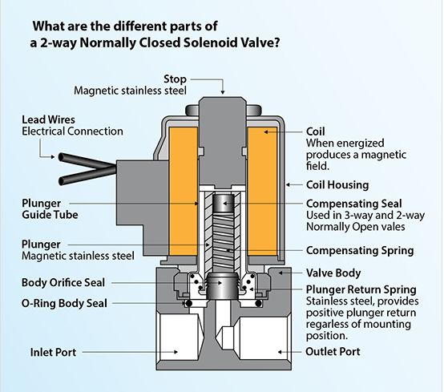

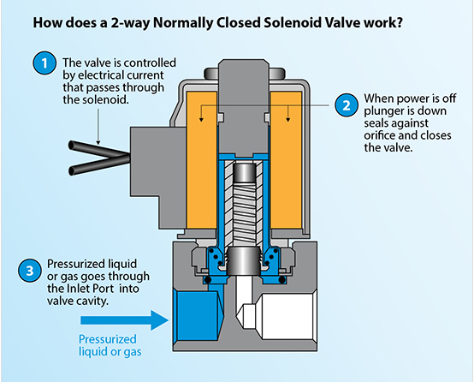

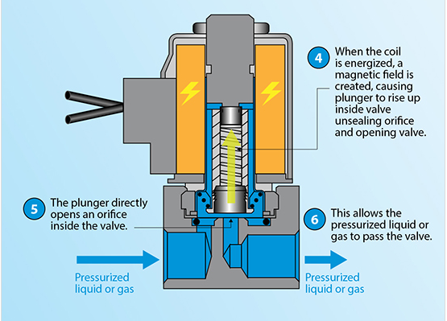

**Controlling A Solenoid Valve With Arduino**

## Step 1: Parts

• Arduino board  
• USB cable for programming and powering the Arduino  
• Breadboard   
• Some jumper cables  
• A 1K resistor  
• TIP120 transistor (TIP102 will also work fine)  
• 1N4004 diode (1N4001 also works)  
• Some batteries and connectors for solenoid power  
• A solenoid with leads to connect to the breadboard

## Step 2: Building the Circuit - Power Connections

USB powers the arduino, the batteries power the solenoid. A jumper grounds the two together.

## Step 3: Building the Circuit - Transistor Time

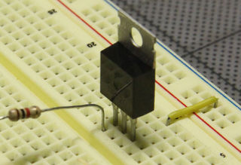

 When the transistors labeled side is facing up the legs (from left to right) are B, C, E: Base, Collector, Emitter.  
  
We will connect the output pin of the arduino to the Base leg of the transistor through a 1K resistor.  The Collector leg of the transistor will be connected to the ground leg of the device we are driving (our solenoid).  The Emitter leg is connected to the ground channel of our circuit.

## Step 4: Building the Circuit - Connecting the Solenoid

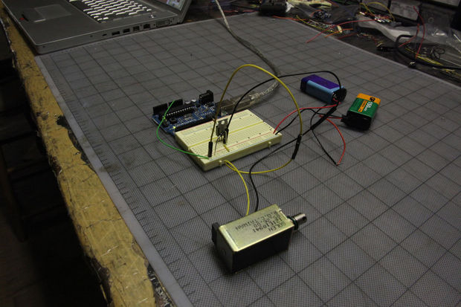

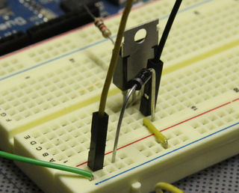

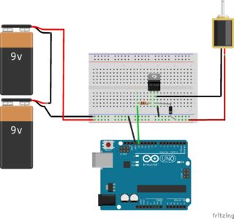

The "ground" leg of the solenoid is connected to the collector leg of the transistor.  The "power" goes to the high voltage power channel (from our batteries).  I put "ground" and "power" in quotation marks because none of the solenoids I've ever used have been polarized so it doesn't matter which lead is connected to ground and which goes to power.    
  
The diode connects the power channel to the solenoid-ground-leg/transistor-collector-leg, preventing the kickback voltage from damaging the circuit.  The diode is polarized and should be oriented with white/sliver stripe on the power channel side of the connection.  
  
I'm using a pull-type solenoid rated for 12 to 24 volts, which has plenty of kick.  You'll need some kind of spring to pull the shaft back out after it's been pulled in - I used a small length of insulated wire wrapped around the shaft to create a makeshift spring.  In a different sort of configuration one could use gravity to pull the shaft back out (but you'd need some of stopper to prevent the shaft from falling all the way out).

## Step 5: Program Arduino and Enjoy

Now just program the Arduino to drive the appropriate output pins and enjoy.  I've connected the transistor to pin 13 so I can see the built-in LED work in time with the solenoid.  The sketch I've used is a simple modification of the "Blink" sketch where I've reduced the on time to 80 milliseconds, which is more than enough time to pull the solenoid all the way in.

Referred From:

<http://www.instructables.com/id/Controlling-solenoids-with-arduino/>

**Writing The Code**

We are starting with the BareMinimum Sketch found in the IDE, it should look something like this:

void setup() {

// put your setup code here, to run once:

}

void loop() {

// put your main code here, to run repeatedly:

}

So first we will need a variable for the Arduino pin:

int solenoidPin = 4; //This is the output pin on the Arduino we are using

void setup() {

// put your setup code here, to run once:

}

void loop() {

// put your main code here, to run repeatedly:

}

Next we need to set the Arduino pin to act as an output:

int solenoidPin = 4; //This is the output pin on the Arduino we are using

void setup() {

// put your setup code here, to run once:

pinMode(solenoidPin, OUTPUT); //Sets the pin as an output

}

void loop() {

// put your main code here, to run repeatedly:

}

Now that it is set as an output we can tell it what to do:

int solenoidPin = 4; //This is the output pin on the Arduino we are using

void setup() {

// put your setup code here, to run once:

pinMode(solenoidPin, OUTPUT); //Sets the pin as an output

}

void loop() {

// put your main code here, to run repeatedly:

digitalWrite(solenoidPin, HIGH); //Switch Solenoid ON

delay(1000); //Wait 1 Second

digitalWrite(solenoidPin, LOW); //Switch Solenoid OFF

delay(1000); //Wait 1 Second

}

So if we want the solenoid to allow water to flow, set the pin high. When you want the water to stop flowing, set the pin low. In this case it will turn the water on for 1 second and then off for 1 second, looping forever (or at least until it is unplugged!) This solenoid valve could easily be used with the flow meter featured in our last tutorial to create a system that only allows a certain volume of water to flow before shutting off.

Reference:

<http://www.bc-robotics.com/tutorials/controlling-a-solenoid-valve-with-arduino/>